**Project Name: E-Mandi**

**Project Member:**

**Sumit Sabbinwar 210543181108**

**Omkar Dalvi 210543181056**

**Aditya Mohite 210543181052**

**Shraddha Kadam 210543181103**

**Abstract:**

E-Mandi is the most effective use of the World Wide Web for raw food industry. The primary goal of **E-Mandi** site is to make Mandi online to reduce time and increase productivity of both farmer as well as buyer. Providing an online approach towards trading of vegetables not only reduces time but also increases the efficiency of the trading process as well as keeps transparency throughout the process.

This project deals with developing a website providing a platform for whole sellers and retailers with an easy interaction. This website makes the trading of crops and vegetables very easy. Buyers can make a bid on particular item they want to purchase. There are two types of login, one is farmer login where the farmer can upload or update posts and another is trader login where he can see various posts and bid on them. The system is implemented using a 3-tier approach with a backend database, a middle tier of Spring Boot and web browser as the front end client.

In order to develop E-Mandi website, a number of Technologies must be studied and implemented. It is a full stack website which includes programming languages such as Core Java, Advance Java, server and client side scripting techniques as React, Spring Boot, relational databases as MySQL.

The objective of this project is to allow buying and selling of Vegetables and Crops with ease and maintain a transparency between the whole seller and retailer. One can easily browse through the various items where he can bid and purchase the items using the interface provided by the system.

**Implementation Technologies:**

1. **Spring Boot :**

Spring Boot is an open source Java-based framework used to create a micro Service. It is developed by Pivotal Team and is used to build stand-alone and production ready spring applications. This chapter will give you an introduction to Spring Boot and familiarizes you with its basic concepts.

Spring enables you to build applications from “plain old Java objects” (POJOs) and to apply enterprise services non-invasively to POJOs. This capability applies to the Java SE programming model and to full and partial Java EE.

**1.1 Features of Spring Boot :**

1. **Web Development**

It is well suited Spring module for web application development. We can easily create a self-contained HTTP server using embedded Tomcat, Jetty or Undertow. We can use the spring-boot- starter-web module to start and running application quickly.

## Externalized Configuration

Spring Boot allows us to externalize our configuration so that we can work with the same application in different environments. Application use YAML files to externalize configuration.

## YAML Support

It provides convenient way for specifying hierarchical configuration. It is a superset of JSON. The Spring application class automatically support YAML. It is successful alternative of properties.

1. **Admin Support**

Spring Boot provide the facility to enable admin related features for the application. It is used to access and manage application remotely.

1. **Security**

Spring Boot applications are spring bases web applications. So, it is secure by default with basic authentication on all HTTP endpoints.

**1.2 Advantages of Spring Boot :**

1. **Starter Dependencies**

**Spring Boot Bundles the right dependencies as starter dependencies.** Starter is just like a Maven or Gradle dependency will all required and commonly used stable versions together very handy.

1. **Spring Boot Auto Configuration**

**Application that interacts with the database using jdbc then you must define a bean with @Bean annotation on a method that returns jdbc Template.**

1. **Spring Boot Command Line Interface (CLI)**

If you use RestController and RequestMapping annotations then CLI knows which starter to be added to the class path to run application.

1. **Spring Boot Actuator**

**This an extremely interesting capability added to spring boot apart from the application development because it gives us the capability toinspect the internal working of application.**

**1.3 JWT (JSON Web Token)**

JSON Web Token, is an open standard used to share security information between two parties a client and a server. Each JWT contains encoded JSON objects, including a set of claims. JWTs are signed using a cryptographic algorithm to ensure that the claims cannot be altered after the token is issued. JWTs are used as a secure way to authenticate users and share information.

**1.3.1 Here are some scenarios where JSON Web Tokens are useful:**

* **Authorization**: This is the most common scenario for using JWT. Once the user is logged in, each subsequent request will include the JWT, allowing the user to access routes, services, and resources that are permitted with that token.
* **Information Exchange**: JSON Web Tokens are a good way of securely transmitting information between parties. Because JWTs can be signed for example, using public/private key pairs you can be sure the senders are who they say they are.

**1.3.2 JSON Web Token Structure**

**JSON** Web Token are one of the way to display data for its transfer between two or more parties as a JSON object.

JWT consist three parts:

* **Header:** A header is a service part of token. It helps the application to define how to process the received token.
* **Payload:** Payload carries any information that helps an application to somehow identify the user. As the field in the payload part can be random, the application can store almost any data in this part.
* **Signature:** The signature and payload parts are encrypted by algorithm and afterwards united in a single box using dot as a divider. Then the signature is generated by algorithm and the signature is added to the initial box after a dot.

1. **ReactJS**

React is a JavaScript library created for building fast and interactive user interfaces for web and mobile applications. It is an open-source, component-based, front-end library responsible only for the application’s view layer. In Model View Controller (MVC) architecture, the view layer is responsible for how the app looks and feels.

* 1. **Features of React JS:**

### One-way Data Binding

ReactJS is designed in such a manner that follows unidirectional data flow or one-way data binding. The benefits of one-way data binding give you better control throughout the application.

### Virtual DOM

A virtual DOM object is a representation of the original DOM object. It works like a one-way data binding. Whenever any modifications happen in the web application, the entire UI is re-rendered in virtual DOM representation.

### Simplicity

ReactJS uses JSX file which makes the application simple and to code as well as understand. We know that ReactJS is a component-based approach which makes the code reusable as your need. This makes it simple to use and learn.

1. **Performance**

ReactJS is known to be a great performer. This feature makes it much better than other frameworks out there today. The reason behind this is that it manages a virtual DOM. The DOM is a cross-platform and programming API which deals with HTML, XML or XHTML. The DOM exists entirely in memory.

* 1. **Advantages of ReactJS:**

1. **Intuitive**

ReactJS is extremely intuitive to work with and provides interactivity to the layout of any UI. Plus, it enables fast and quality assured application development that in turn saves tome for both - clients and developers.

1. **Declarative**

ReactJS enables significant data changes that result in automatic alteration in the selected parts of user interfaces. Owing to this progressive functionality, there is no additional function that you need to perform to update your user interface.

1. **Components Support**

ReactJS is a perfect combination of JavaScript and HTML tags. The usage of the HTML tags and JS codes, make it easy to deal with a vast set of data containing the document object model. During this time, ReactJS works as a mediator which represents the DOM and assists to decide which component needs changes to get the exact results.

1. **Proficient Data Binding**

ReactJS trails one-way data binding. This means that absolutely anyone can track all the changes made to any particular segment of the data. This is a symbol of its simplicity.

1. **MySQL**

MySQL, the most popular Open Source SQL database management system, is developed, distributed, and supported by Oracle Corporation.

**Features of MySQL:**

* **MySQL is a database management system.**

A database is a structured collection of data. It may be anything from a simple shopping list to a picture gallery or the vast amounts of information in a corporate network. To add, access, and process data stored in a computer database, you need a database management system such as MySQL Server. Since computers are very good at handling large amounts of data, database management systems play a central role in computing, as standalone utilities, or as parts of other applications.

* **MySQL databases are relational.**

A relational database stores data in separate tables rather than putting all the data in one big storeroom. The database structures are organized into physical files optimized for speed. The logical model, with objects such as databases, tables, views, rows, and columns, offers a flexible programming environment.

* **MySQL software is Open Source.**

Open Source means that it is possible for anyone to use and modify the software. Anybody can download the MySQL software from the Internet and use it without paying anything.

* **The MySQL Database Server is very fast, reliable, scalable, and easy to use.**

MySQL Server was originally developed to handle large databases much faster than existing solutions and has been successfully used in highly demanding production environments for several years. Although under constant development, MySQL Server today offers a rich and useful set of functions. Its connectivity, speed, and security make MySQL Server highly suited for accessing databases on the Internet.

* **MySQL Server works in client/server or embedded systems.**

The MySQL Database Software is a client/server system that consists of a multithreaded SQL server that supports different back ends, several different client programs and libraries, administrative tools, and a wide range of application programming interfaces (APIs).

1. **Hardware and Software Requirements (Minimum):**

**Hardware:**

1. Intel i5 processor 6th generation

2. 4 GB ram.

3. Windows 10 Home edition

4. 1TB HDD Space

5. Data Connection 200 kbps

**Software:**

1. Eclipse 4.7 IDE
2. MySQL 5.7 with Workbench 8.0
3. Google Chrome version 93.0
4. Apache Tomcat Server 8.5
5. Maven Dependencies
6. **ER Diagram:**

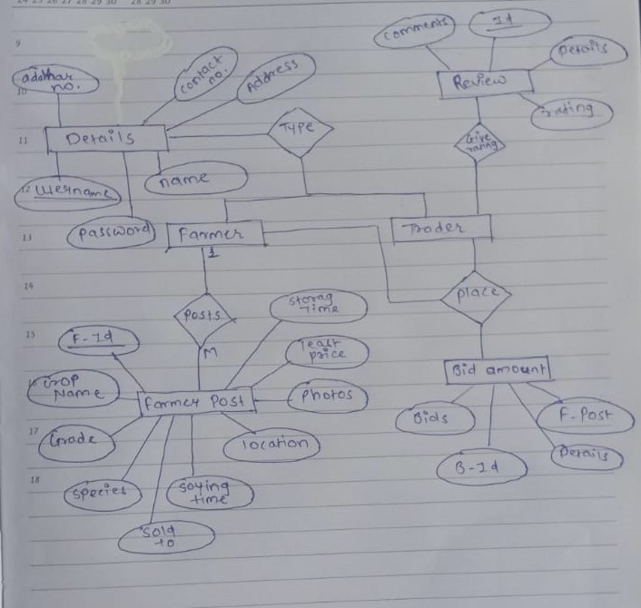

Figure 1: ER Diagram

**6.Table Structures:**

1. **Table Name: Details**

**Column name Type**

Username varchar PRI

Password varchar(20) YES

Type varchar(20) YES

Name varchar(40) YES

ContactNo varchar(20) YES

Address varchar(20) YES

Adhaar No varchar(20) YES

1. **Table Name: Farmer Post**

**Column name Type**

F_Id int (11) NO PRI

Farm varchar(50) YES MUL

Crop Name varchar(10) YES

Species varchar(30) YES

Grade varchar(50) YES

Soying Time varchar(30) YES

Location varchar(30) YES

Storage Time varchar(30) YES

Quantity varchar(30) YES

Photos varchar(30) YES

Least Price varchar(30) YES

Status Bool YES

1. **Table Name: Bid**

**Column name Type**

Bid_Id int (11) NO PRI

FarmerPost int (11) YES MUL

Bids varchar(40) YES

Details varchar(100) YES MUL

1. **Table Name: Review**

**Column name Type**

Id int (11) NO PRI

Deatils int (11) YES MUL

Rating varchar(100) YES

Comments varchar(100) YES

F_Id int (11) YES MUL

1. **UML Diagrams:**

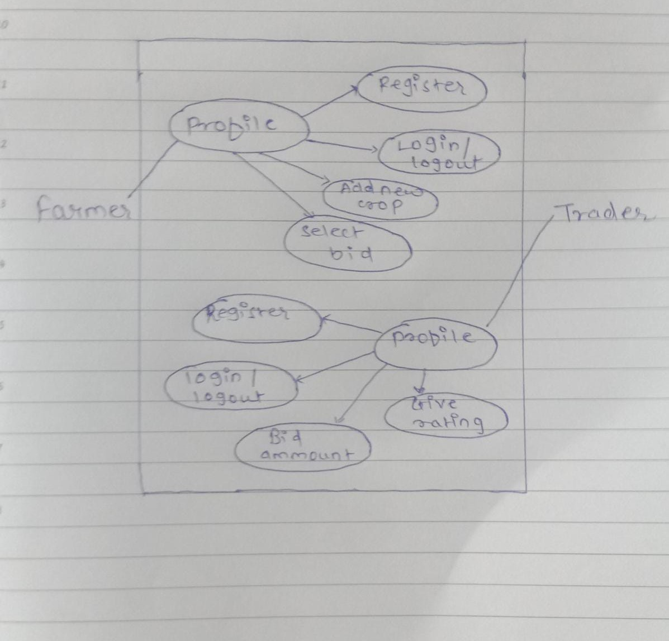

Figure 1: Use Case

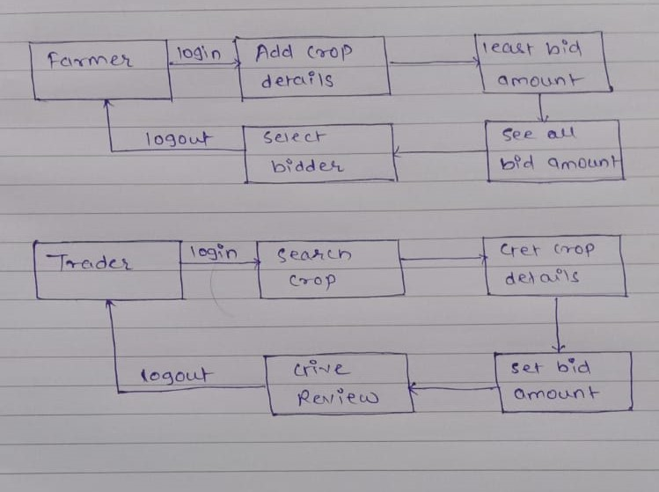

Figure 2: Collaboration Diagram

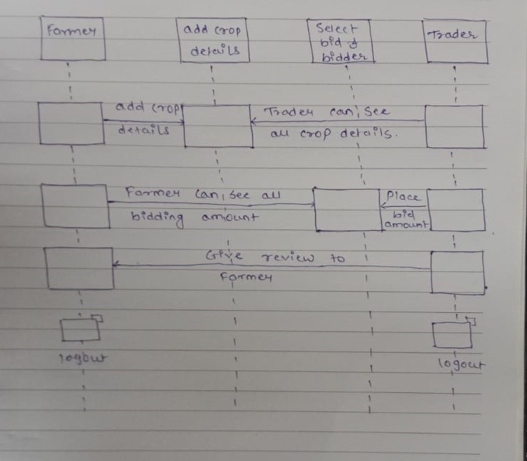

Figure 3: Sequence Diagram

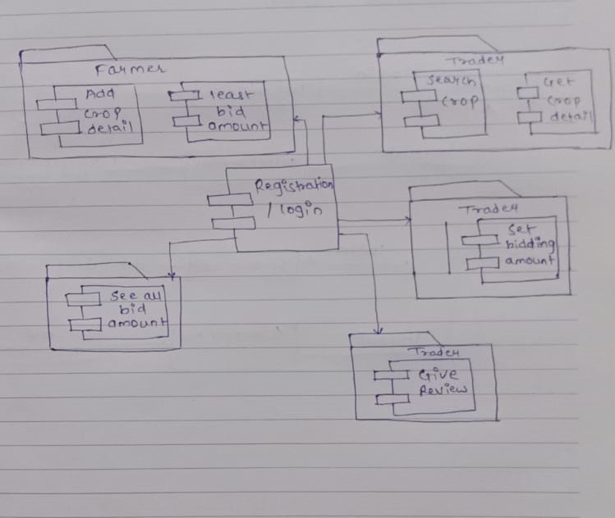

Figure 4: Component Diagram

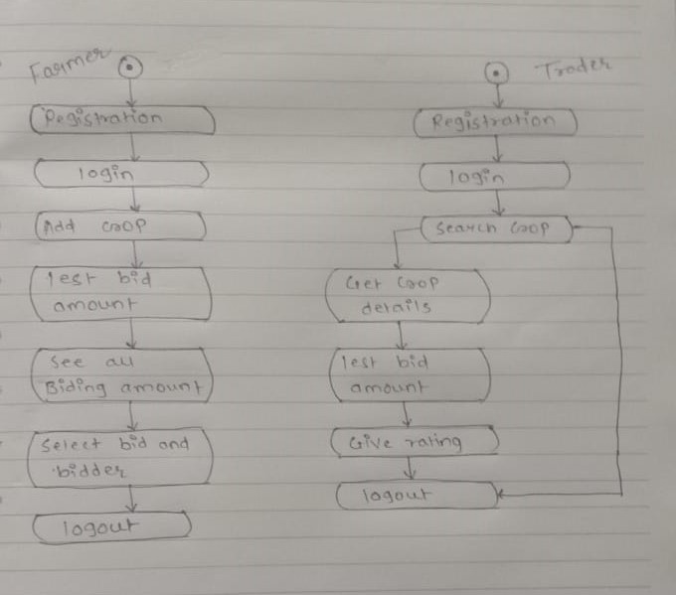

Figure 5: State Diagram

n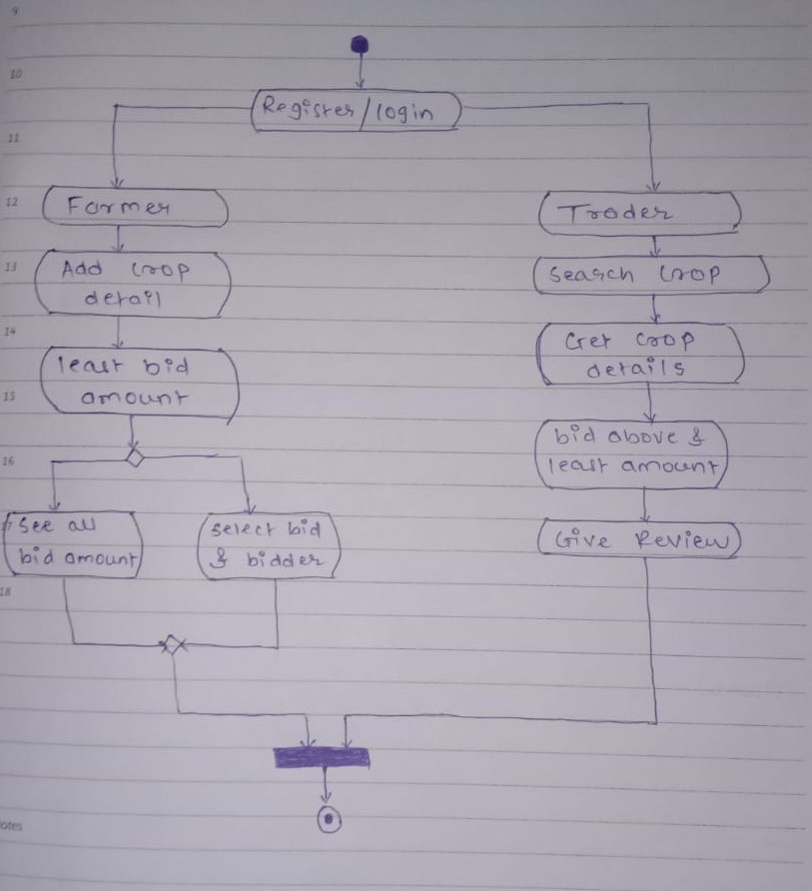

Figure 6: Activity Diagram

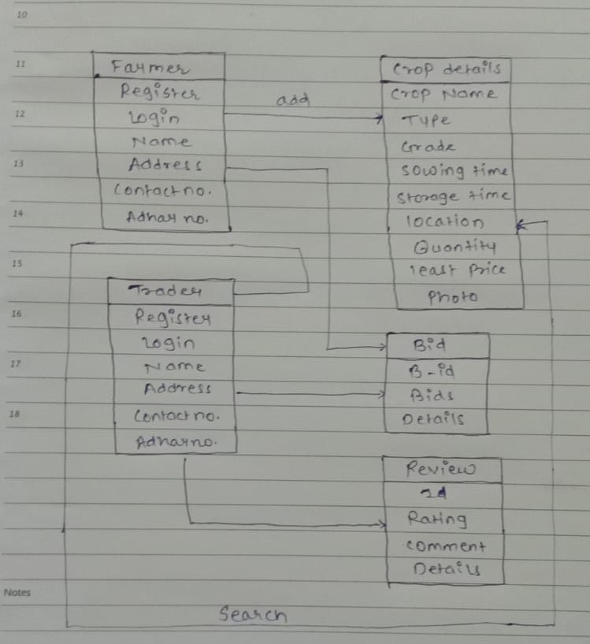

Figure 7: Class Diagram

1. **End to End Flow of Application:**

**Farmer:**

* 1. Farmer will login to the portal or will have to register if he is not a registered user.
  2. After registration Farmer will login and farmer can add new crop and its details.
  3. Farmer can place the bid amount of the particular crop and he can see the biding amount which is placed by the Trader.

**Trader:**

1. Trader will login or will have to register if he is not registered user.
2. After login he can search for the crop that he want and see the details about the crop, He will also place the biding amount for the crop.
3. He can view the farmer details and he will give the review to that farmer.

1. **Future Scope :-**

* As estimated time is available, delivery options can be implemented to nearby locations.
* Predictions of crop that can be cultivated in a certain region according to geographical conditions can be provided.
* Chat box can be provided for interaction between farmers and traders.
* Additional features can be added by creating mobile application making it more easily accessible

**Thank You!**